Fall 2020

CS 5100 - Final Project Report

Artificial Intelligent Based Poker Game: Doudizhu

by

Qi Zhang

Peng Han

Prefix

Dou Dizhu is a popular poker game in China. The name Dou Dizhu literally translates as Fight the Landlord, which refers to the class struggle that happened in China during the transition from feudal society to the new China. In the 1950s after the Chinese Communist Party took over China, peasants took up arms against the landlords. Though the class struggle between peasants and landlords ended decades ago, the game has been passing on through generations after generations. Today it has become one of the most popular card games in China.

Game Play

Dou Dizhu requires three players and one pack of cards, including the two differentiated jokers. Among the three players, one player plays the landlord, and two other players both play the peasants and need to work together against the landlord. The objective of the game is to be the first player to have no cards left.

When the game starts, a shuffled pack of 54 cards is dealt to three players. Each player is dealt 17 cards, with the last three leftover cards detained on the playing desk, face down. All players first review and appraise their own cards without showing their cards to the other players. Then, players take turns to decide if they want to be the landlord position. The first player decides to be the landlord and will play the landlord position in this game. The other two players automated play the peasant position. If the first two players both do not want to play the landlord position, the last player automatically plays the landlord position. Then the three leftover wild cards are revealed to all players before being dealt to the landlord.

The landlord starts the first round by playing any Combination he/she desires, and every player plays in order if they can beat the previous cards. Until no one can beat the cards, that player starts the new round with any Combination. In the end, The landlord wins if he or she has no cards left. The peasant team wins if either of the peasants have no cards left.

Card Combinations:

**Name Description Example**

Solo any single card 2 > A

Pair Two cards of same rank Q-Q > 3-3

Trio Three cards of same rank 2-2-2 > 3-3-3

Trio + Solo Three cards of same rank 5-5-5-3 > 4-4-4-A

following one single card

Trio + Pair Three cards of same rank 5-5-5-3-3 > 4-4-4-A-A

following a Pair

Chain ≥ Five consecutive Solo 8-9-10-J-Q > 3-4-5-6-7

Pair Chain ≥ Three consecutive Pair 8-8-9-9-10-10 >

3-3-4-4-5-5

Airplane ≥ Two consecutive Trio 8-8-8-9-9-9-10-10-10 >

3-3-3-4-4-4-5-5-5

Airplane with Airplane + the same number A-A-A-2-2-2-3-4 >

Wings of Solo or Pair Q-Q-Q-K-K-K-6-A

Bomb All four of the same rank 2-2-2-2 > A-A-A-A

cards

Rocket Both jokers > everything

Rules

* Rocket > everything
* Bomb < Rocket, but > everything else. Bomb with larger rank > Bomb with smaller rank
* Besides Rocket and Bomb, a player can only beat the prior hand using the same Combination but not the others.
* Individual cards are ranked. Colored Joker > Black & White Joker > 2 > Ace (A) > King (K) > Queen (Q) > Jack (J) > 10 > 9 > 8 > 7 > 6 > 5 > 4 > 3. Suits are irrelevant.
* Compare only the Chains with the same length
* Jokers and 2 Cannot be used in Chain

Design

In our project, there are three players in the game. Player I and Player II are our computer Artificial Intelligence agents, and Player III is the human player. The AI algorithms that we are using in our project are A*Search and Greedy Search. When each game starts, the game manager will shuffle the deck and deal 17 cards to each player, leaving three wild cards on the table. All three player will decide if they will want to be the landlord. After the landlord is decided, the three additional cards on the board then will be moved into its hand. Then the game starts.



As the game starts, the landlord player will be the first one to play its cards. If the landlord is an AI player, firstly, we will check if there are any cards on its hand. As this is the first round, that statement is obviously true. Then we will check all the cards on its hand, and then decide if this turn is a play turn or call turn. As the first turn is always the landlord’s play turn, then we will check all the legal actions of all the cards on its hand and play with the combination with the highest score. Then the landlord player’s turn ends and the next player’s turn starts. Then we repeat the loop until eventually there is one player with no cards on its hand, then the game ends.



Methodology

We divide the project into 5 parts. Card Class handles everything card related such as assigning suit, rank and value to each card. Deck Class handles shuffle cards and clear cards. Hand Class handles add cards to the players’ hand and remove cards from the players’ hand. Player Class handles whether the player is landlord or peasant. Lastly, the Manager Class is responsible to check all the legal actions based on the cards on each player’s hand, and also handles the AI algorithms and their utility functions.

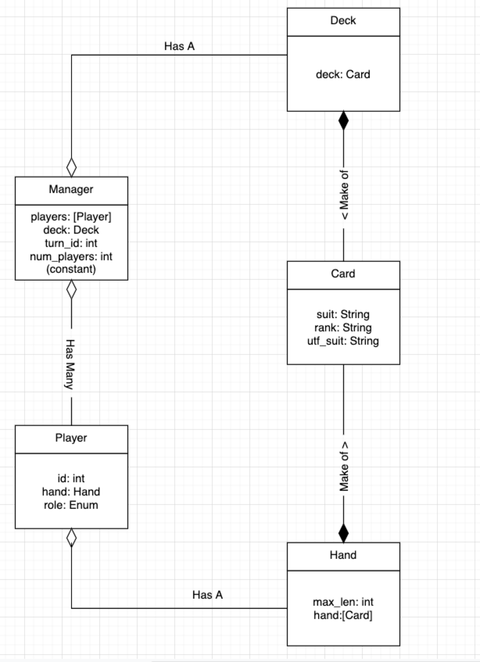

Result

Both AI in our project are able to follow the rules of the game and play their cards based on their individual optimal results. In general, we are happy to see that our AI can use different algorithms to play against human players and sometimes even manage to win the game.

Future Scope

As for the AI perspective, we can implement more sophisticated AI algorithms for the Player AI, such as using reinforcement learning. Besides that, we would also want to add features that will let all players be able to see the number of cards in each players’ hand, which help to improve the usage of gameplay strategy. Lastly, one of the functions that we really like to add on our AI player is the ability to teamwork when both of them play as peasants.

For the UI perspective, first of all, we can improve the user experience by changing the input from the index of the card to the rank of the card. Other than that, we can also largely improve the entertaining of the game by constructing user friendly web UI and implement graphics and animations to better represent the gameplay.